PRIMARY SEVEN
CONTINUOUS ASSESSMENT
INTERGRATED SCIENCE PAPER (SET 2)

TIME: 2 HOURS 15 MINUTES

Index No.

Candidate’s Name …………………………………………………………..
Candidate’s Signature ……………………………………………….…….
School Name ……………………………………………………………….
District Name ………………………………………………………………

DO NOT OPEN THIS BOOKLET UNTIL YOU ARE TOLD TO DO S
Read the following instructions carefully.

- This paper is made up of two Sections: A and B.

- Answers to both sections must be written in the spaces provided in full sentences.

- Section A has 40 questions (40 marks)

- Section B has 15 questions (60 marks)

- Attempt all questions. All answers to both sections A and B must be written in the spaces provided.

- All answers must be written in blue or black ballpoint pen or ink but not in pencil. All work done in pencil, except diagrams, will NOT be marked.

- Crossing out of answers will lead to loss of marks.

- Any handwriting that cannot be easily read may lead to loss of marks.

FOR EXAMINERS USE ONLY
QN. NO. | MARK | SIGN
1 - 10
11 - 20
21 - 30
31 – 40
41 – 43
44 – 46
47 – 49
50 – 52
53 – 55

SECTION A. (40 MARKS)
- Name any one insect vector.
_________________________________________________________________
- Apart from controlling soil erosion, give any other use of mulching a garden.
_________________________________________________________________
- Why does heat travel through both liquids and gases by convection?
_________________________________________________________________
- State the disadvantage of keeping a magnet facing East –West direction for a long time.
_________________________________________________________________
- How does the use of artificial fertilizers on land cause water pollution?
__________________________________________________________________________________________________________________________________
- Which layer of the soil profile contains more living organisms?
_________________________________________________________________
- Why does a person with HIV become vulnerable to other infections?
__________________________________________________________________________________________________________________________________
The diagram below shows a creeping stem. Use to answer question 8 and 9.
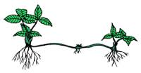
P

T

- Name the roots of the plant above marked with letter T.
_________________________________________________________________
- Of what use is part P to above plants?
_________________________________________________________________
- Give any one sign farmer can use to detect a sick goat on a farm.
_________________________________________________________________
- State any one requirement for starting a livestock farm.
_________________________________________________________________

- Calculate the density of an object whose mass is 10gm and has volume of 5cc.

- Name the type of lens used to correct short sightedness.
_________________________________________________________________
The diagram below is of a packet in which a doctor put tablets for a patient. Use it to answer questions 14 and 15.

KIREKA JOINT CLINIC
Name of Drug
Chloroquine
Dosage 2 x 3
To be taken after a meal

Doctor’s writings

- What do we call the doctor’s writings on the envelop?
_________________________________________________________________
- Give one importance of the doctor’s writings on the packet to patients.
_________________________________________________________________
- How is a moss plant different from a bean plant?
__________________________________________________________________________________________________________________________________
- Which body organ in human beings is similar to gills of fish by function?
_________________________________________________________________
- In which way do wetlands increase the spread of malaria in an area?
_________________________________________________________________
- Write any one activity one can carryout to promote PHC.
_________________________________________________________________
- Suggest any one way of conserving petroleum as a non-renewable resource.
_________________________________________________________________

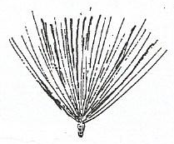
The diagram below is of a seed dispersed by wind.
X

- How does part X enable this seed to be dispersed by wind?
_________________________________________________________________
- Identify any one symptom of tooth decay.
_________________________________________________________________
- Why do some farmers prefer rearing goats to cattle?
__________________________________________________________________________________________________________________________________
- Name one form of energy produced by burning wood fuel.
_________________________________________________________________
- Suggest any one way farmers can prevent their bees from swarming.
_________________________________________________________________
- Mention any one example of anti-social behaviour among youth.
_________________________________________________________________
- Describe the first aid you would give to a victim whose hand is burnt by hot porridge.
__________________________________________________________________________________________________________________________________
- Which system of grazing cattle can easily be carried out in urban areas?
_________________________________________________________________
- Name the gas used to preserve bottled drinks like soda.
_________________________________________________________________
- Give any one difference between mosses and mushrooms.
__________________________________________________________________________________________________________________________________

Below is a diagram of a tadpole. Use it to answer question 31.
Tail.

External gills

- What is the function of the external gills shown above to a tadpole?
_________________________________________________________________
- Which product produced by a sheep is useful in the cloth making industry?
_________________________________________________________________
- A ray of light strikes a plane mirror at an angle of 30⁰. Calculate the size of an angle of incidence.

- Why is photosynthesis in plants considered a chemical change?
_________________________________________________________________
- How does immunization promote the health of children?
_________________________________________________________________
- Give any one example in which the filtration process is used at home.
__________________________________________________________________________________________________________________________________
- How does terracing of land help to prevent soil erosion?
_________________________________________________________________
- Mention one way through which foot and mouth disease is spread among cattle.
_________________________________________________________________
- Why is carbon dioxide used in a fire extinguisher?
_________________________________________________________________


The diagram below shows a bicycle hub. Use it to answer quest 40.
Ball bearings

- What is the use of ball bearings in the hub shown below?
_________________________________________________________________
SECTION B.
- Apio put two spoonful of sugar in hot water and stirred for two minutes.
- What do you think happened to sugar?
________________________________________________________________
- Name the type of solution Apio made.
_________________________________________________________________
- Identify the solute and the solvent in the above mixture.
(i)solute___________________________________________________________
(ii)solvent__________________________________________________________
- (a) Mention any one example of a;
- Cereal crop___________________________________________________
- Legume crop__________________________________________________
(b) Non flowering plants are divided into spore bearing plants and seed
bearing plants. Give one example of each;
(i) spore bearing.___________________________________________________
(ii) seed bearing.____________________________________________________
- (a) Name the best food for newly borne babies.
_________________________________________________________________
(b) What do well call a meal with food values in right portions?
_________________________________________________________________
(c) Identify the malnutritional disease children develop due to lack of;
(i) Proteins ________________________________________________________
(ii) carbohydrates __________________________________________________

- Below are diagrams of blood vessels. Use them to answer the given questions.
A
B
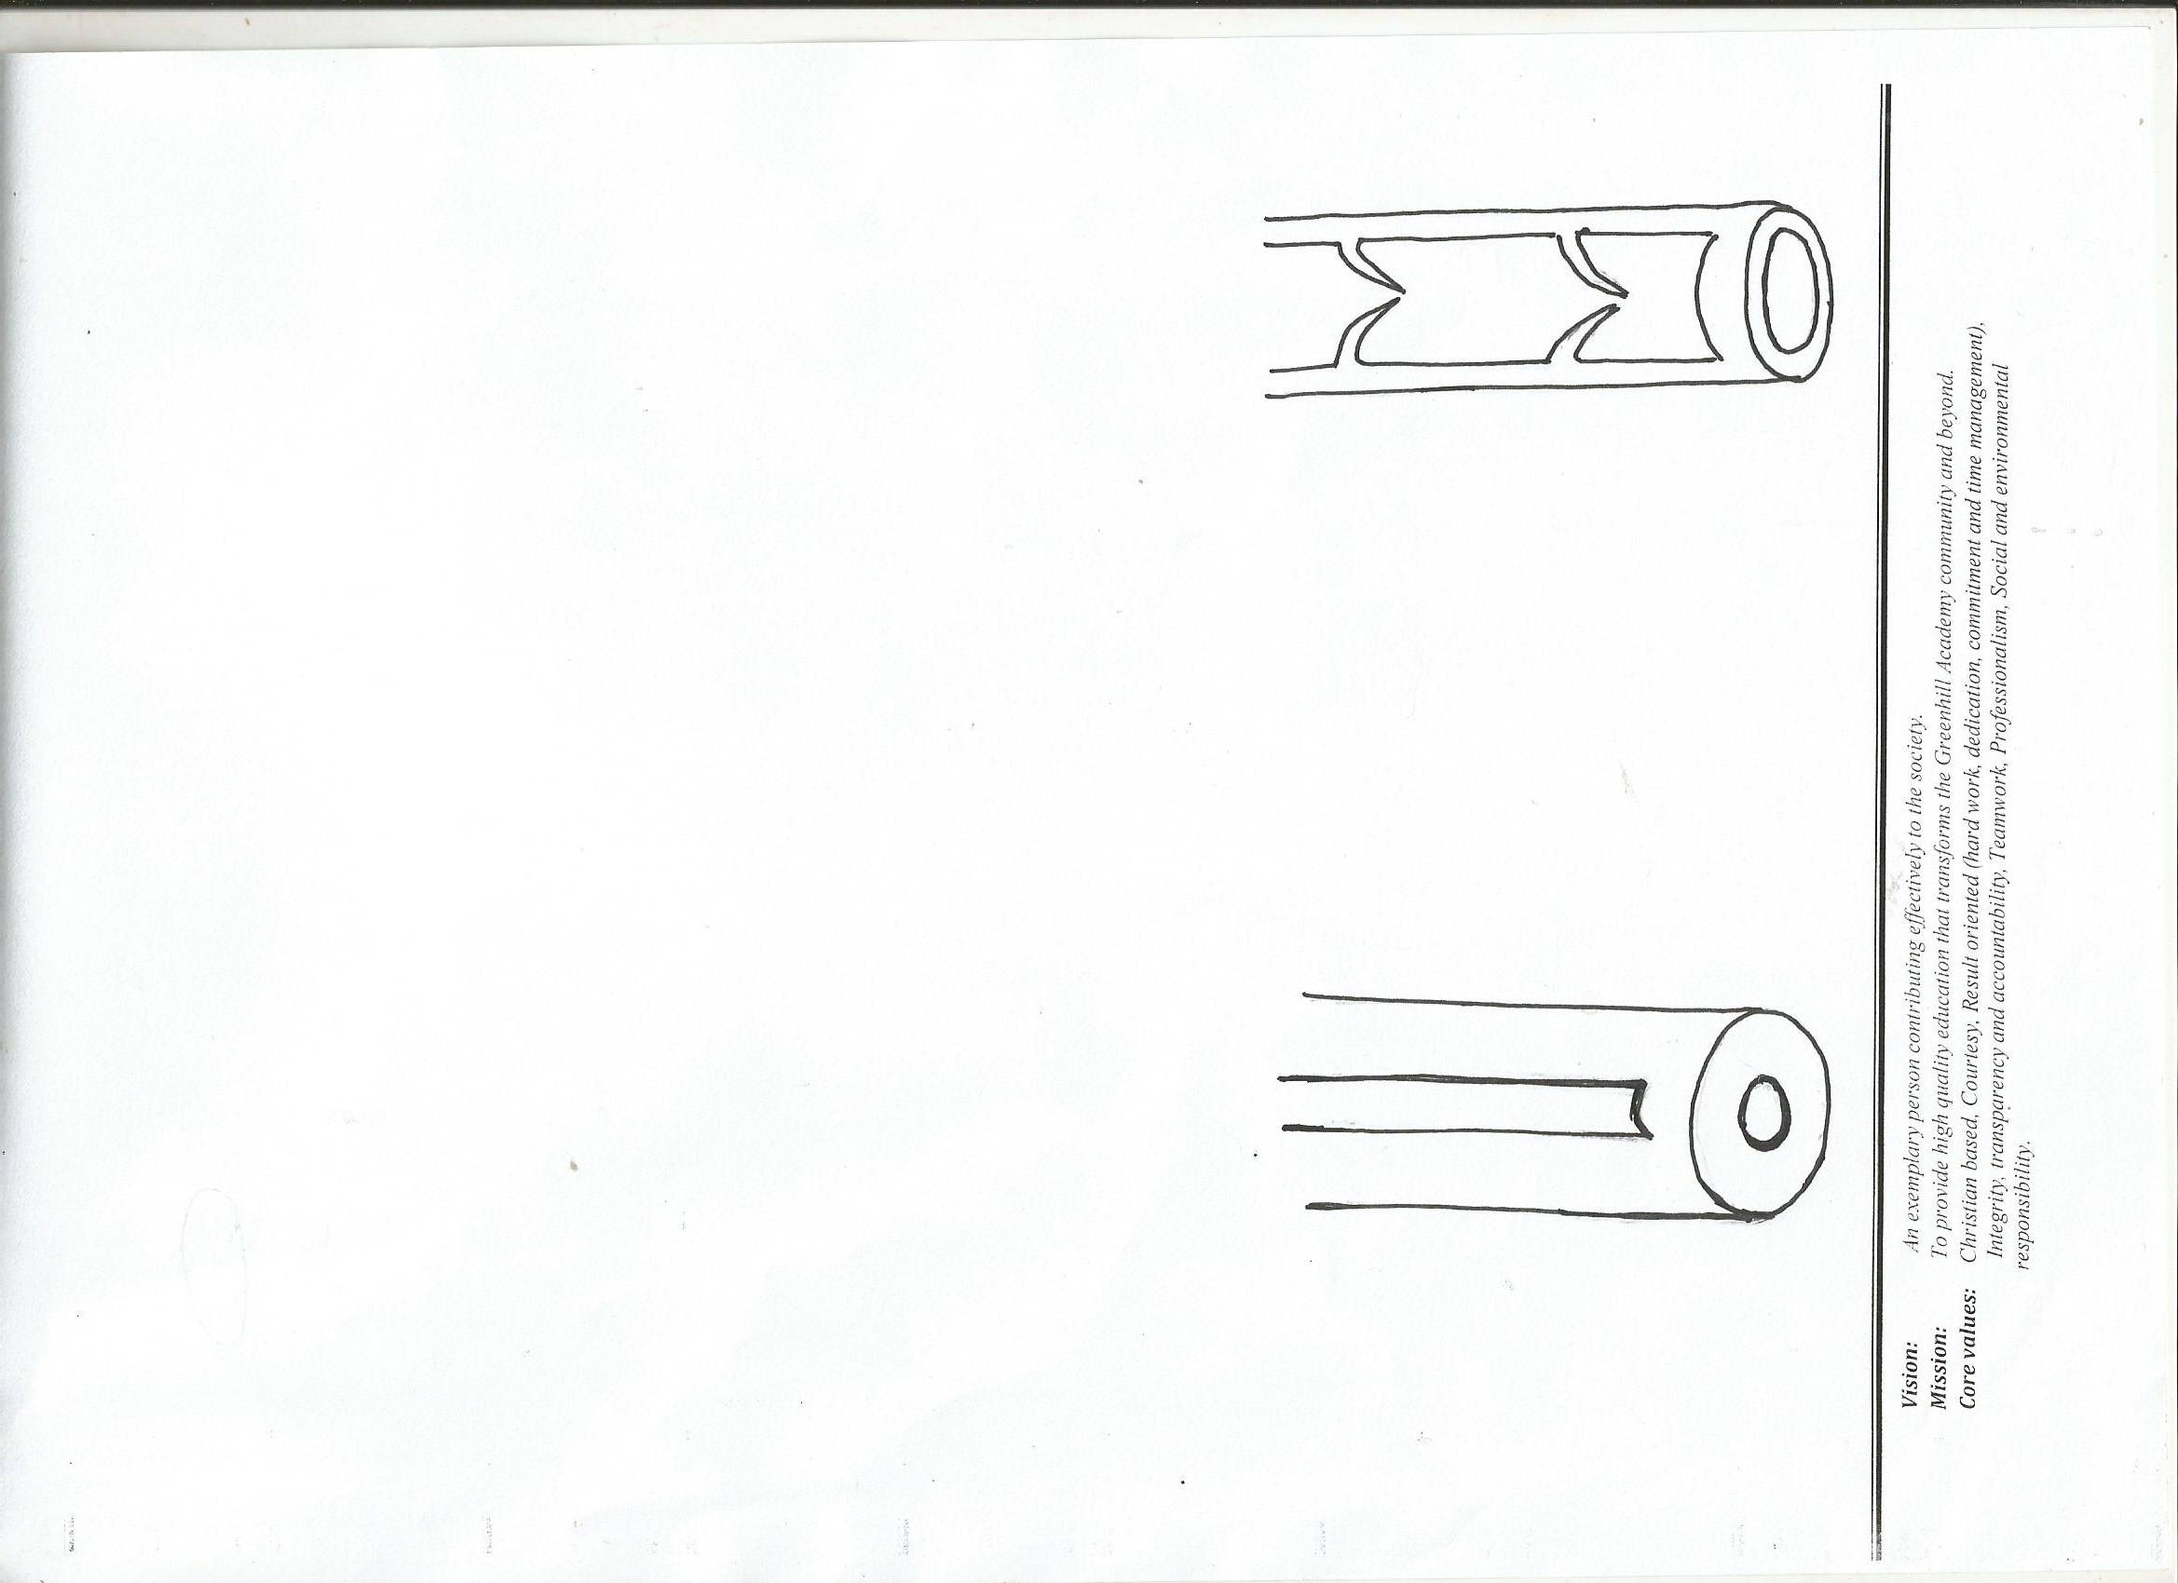

- Name the type of blood vessels A and B.
(i)A ____________________________ (ii) B_____________________________
- Give one structural difference between blood vessel A and B.
__________________________________________________________________________________________________________________________________
- What type of blood is mainly carried along blood vessel A?
_________________________________________________________________
- (a) Give any two components of soil.
(i)________________________________________________________________
(ii)_______________________________________________________________
(b)Identify the type of soil best for
(i) growing crops.
_________________________________________________________________
(ii) making pots
_________________________________________________________________
- (a) Give any two examples of commonly abused drugs in Uganda.
(i)________________________________________________________________
(ii)_______________________________________________________________
(b) Name any one body organ affected by cigarette smoking.
_________________________________________________________________
(c) State any one excuse people give for taking alcohol.
_________________________________________________________________

- Complete the table below correctly.
Form of electricity | Source of electricity
Thermal electricity | ______________________________
_____________________________ | uranium
Hydroelectricity | ______________________________
_____________________________ | sun

- (a) What do you understand by the term Dual purpose cattle?
__________________________________________________________________________________________________________________________________
(b) Mention any two examples of dairy breeds of cattle.
(i)________________________________________________________________
(ii)_______________________________________________________________
(c)Cite any one physical characteristic of dairy cattle.
_________________________________________________________________
- Below is an example of a food chain. Study it and answer questions 49.
Grass Locust Fowl.
- Identify the following organisms from the above food path.
(i)secondary consumer _______________________________________________
(ii)Producer _____________________________________________________
- What do arrows represent from the above food path?
_________________________________________________________________
- Name the source of energy for the grass to make their food.
_________________________________________________________________

- The diagram below is of a lifecycle of a housefly. Study it and answer the questions about it.
Adult
Larva
B

A

(a)Name the stages marked A and B.
(i) A__________________________ (ii) B _____________________________
(b) How is the adult stage of the above insect dangerous to people?
_________________________________________________________________
(c) What type of metamorphosis is shown in the above diagram?
_________________________________________________________________
- (a) What are resources?
_________________________________________________________________
(b) Write down any one example of the following types of resources.
(i) Renewable resources
_________________________________________________________________
(ii) Non-renewable resources.
_________________________________________________________________
(c) How can we conserve forests as resources in the environment?
_________________________________________________________________
- (a) What type of skeleton do the following organisms possess?
(i) slug ___________________________________________________________
(ii) rat ____________________________________________________________
(b) Give the importance of joints in the human body.
_________________________________________________________________
(c) Write any one use of skeleton to people.
__________________________________________________________________________________________________________________________________

- (a) Name the vector that spreads nagana to livestock.
_________________________________________________________________
(b) Give any two ways of controlling the vector mentioned above.
(i)________________________________________________________________
(ii)_______________________________________________________________
(c) write any one use of livestock to people.
_________________________________________________________________
- The diagrams drawn below are of garden tools. Use them to answer
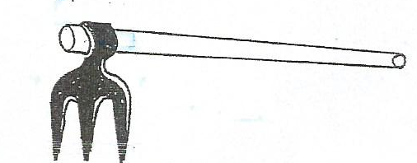
question
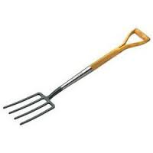
A
B

(a) Which of the above tools is suitable for
(i) turning compost manure in the pit?
_________________________________________________________________
(ii) digging rocky soil?
_________________________________________________________________
(b) Give any two ways of protecting garden tools from rusting.
(i) _______________________________________________________________
(ii)_______________________________________________________________
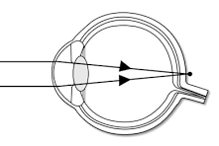
- The diagram below shows an eye defect.

- Name the eye defect shown above.
_________________________________________________________________
- Give the cause of the eye defect shown above.
_________________________________________________________________
- Draw and name the lens used to correct the eye defect above.
END.

